Software Engineering UML

Connor Jackson, Adam Claxton

9/21/2015 Section 002L

1. Here the AbstractHTMLView is an Abstract9Calendar, and it has access to the same functions. HTMLMonthlyView, HTMLCompactWeekView, and HTMLWeekView can all provide html by calling methods from their immediate parent, AbstractHTMLView, and methods further up in the hierarchy from AbstractCalendar.

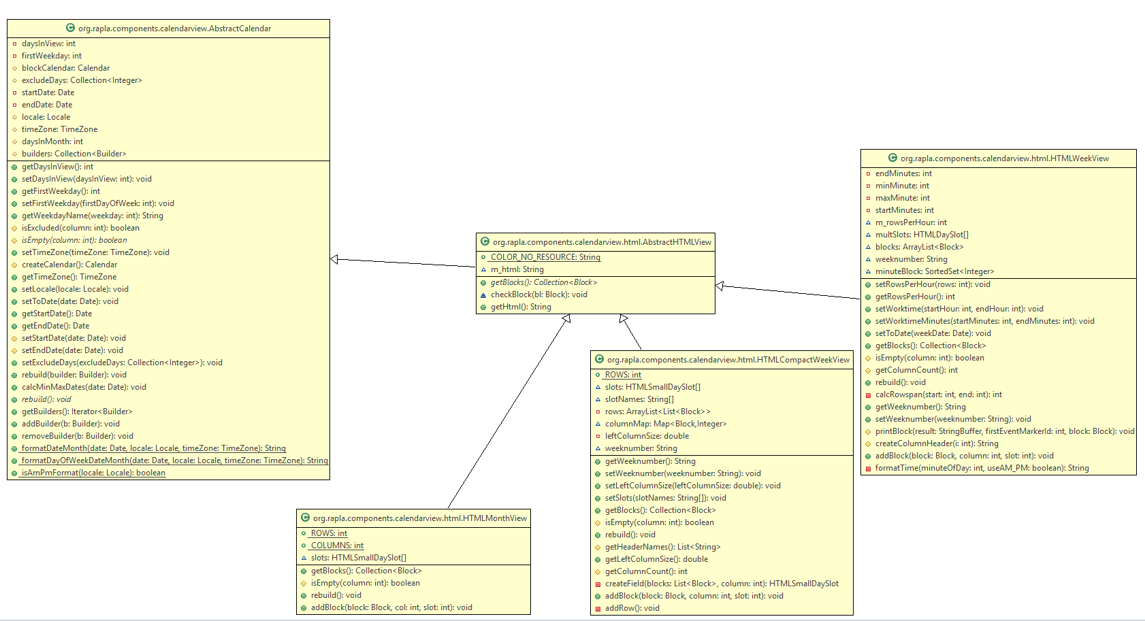

2. Whenever a RaplaTime instance is created, it invokes the TimeField constructor. RaplaTime takes a time and assigns it to a new event. RaplaTime gets the desired time by using TimeField to directly parse a user’s input into a format it knows how to handle.

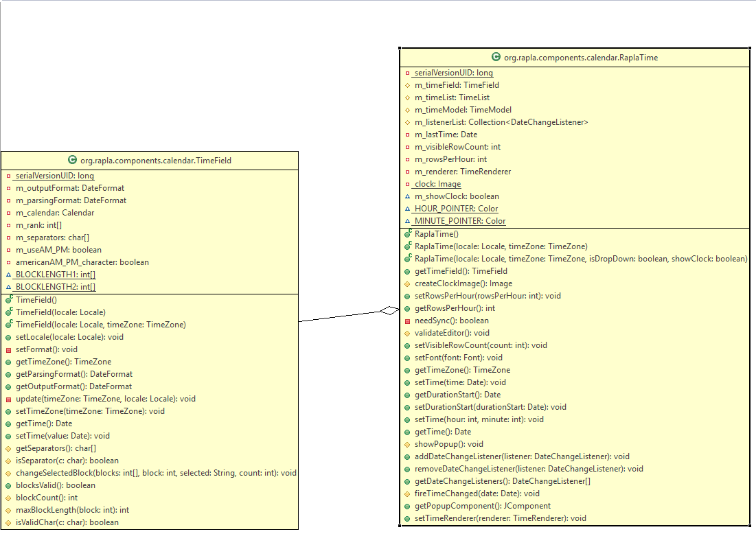

3. StartupEnvironment provides empty methods that should be designed in the classes that implement it, as we see that each of the 6 methods in the interface exist in RaplaStartupEnvironment and SimpleConnectorStartupEnvironment. Interfaces allow us to require actions in areas of our code that implement it, but allow us to slightly alter each action, based on where it’s performed.

